*Virus Recovery*

Angela Tseng

School of Computing and Information

University of Pitttsburgh

aat52@pitt.edu

# Abstract

Project “Virus Recovery,” led and completed by a single member, Angela Tseng, examines the research question; “How does the location of an individual affect their chance of recovering from the coronavirus?” This question interested me due to its current impact on society; every individual in the world right now has been affected by this historical event, whether directly or through social stigmatization. This project is intended to direct attention away from the panic surrounding the virus. Instead, it focuses on the recoverability of the illness in order to help contain or provide the best resources for those affected. Ideally, through analysis of the data, insight will be provided about which countries are handling the virus the most effectively. From this, other countries can observe their precautions and methods, and hopefully provide better resources for their people. The overall plan for analysis is to use data munging and data visualization methods on the dataset John Hopkins University has published to observe geographical trends.

# Introduction

In December of 2019, China reported an outbreak of a new coronavirus in Wuhan, Hubei Province. Since then, the virus has spread across the world, infecting over a million people [1]. It was originally known as the “2019 novel coronavirus,” and is caused by a coronavirus called SARS-CoV-19. Later in February, the World Health Organization announced the official name for the disease, coronavirus disease 2019, abbreviated as COVID-19 [2]. The virus spreads from person to person through airborne droplets and causes a variety of respiratory reactions along with fever and cough [2]. Countries around the world have attempted to contain this virus, or “flatten the curve,” through different safety measures; ordering people to stay home, inspecting international travelers, and redistributing resources. Ideally, fewer people will be infected at a time and therefore fewer people will need to be hospitalized, which puts less strain on a country’s healthcare system.

The virus has now made a significant impact in various countries; most notably Italy and the United States, where the number of infected seem to only be increasing [3, Fig. 1]. It is well known at this point that areas such as Taiwan and South Korea that practice strict quarantine procedures and proactively contain the virus have been able to stop the exponential growth of confirmed cases.

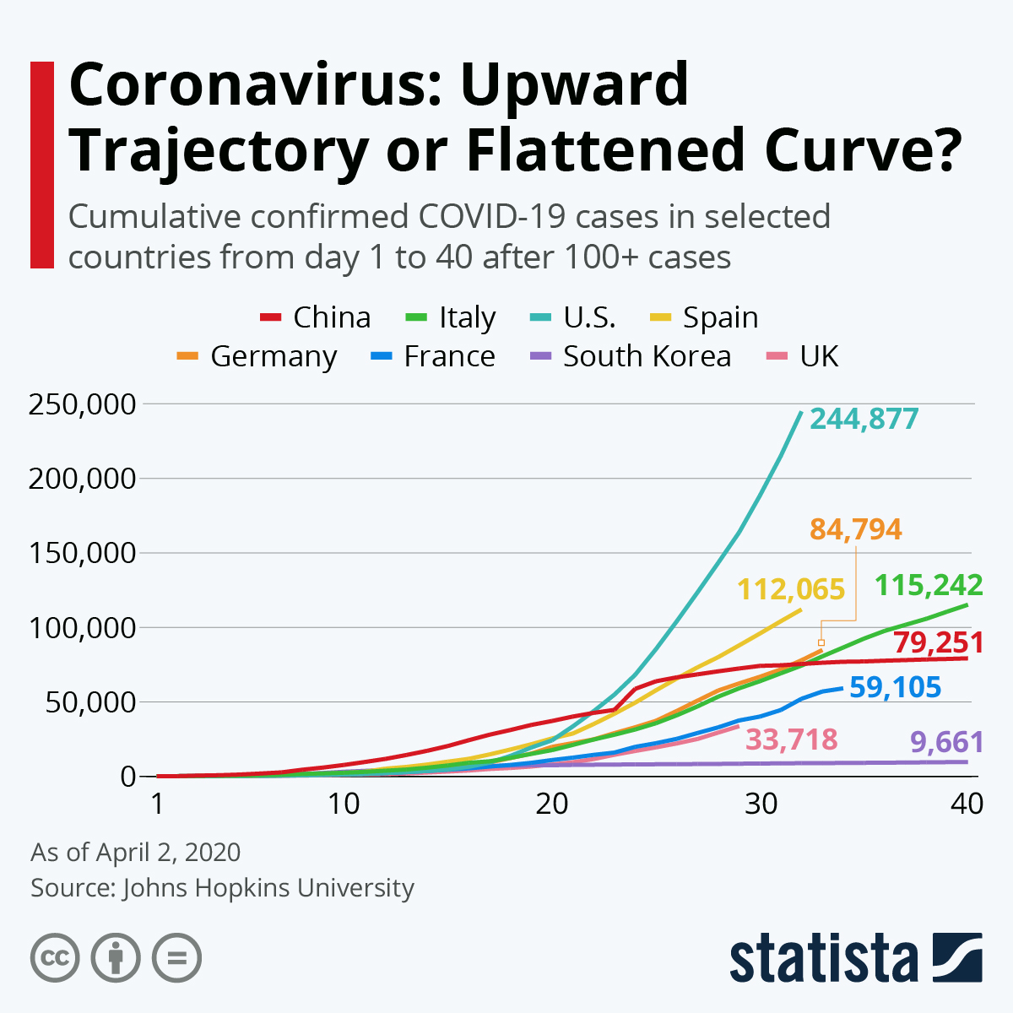

Fig. 1. Graph of cumulative confirmed cases.

The purpose of this paper is to take a look at countries that are recovering best from the impact of the virus. Ideally, the observations made from this research will help struggling countries identify successful methods in combatting this pandemic.

# Methodology

The data was downloaded off of the John Hopkins coronavirus tracking website as csv files. There are three files; one for confirmed cases, one for recovered patients, and one for the number of deaths. These files are updated daily, but the pictures used in this paper are from 8 April 2020. Images and values used in this paper may not reflect current statistics.

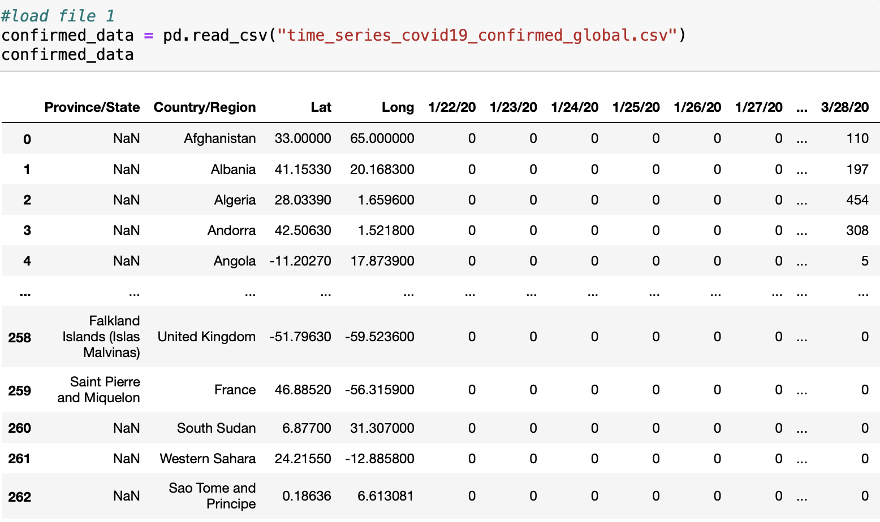

Fig. 2. Example of original confirmed cases csv file.

After loading the appropriate tools along with all three files, the data can be prepared for cleaning, scaling, transforming, and analysis. All three files undergo the same preparation. Calculate and append the sum of each row as a separate column at the end of the file. Consequently, the individual columns representing counts for each day are no longer relevant, so they can be dropped [Fig. 3].

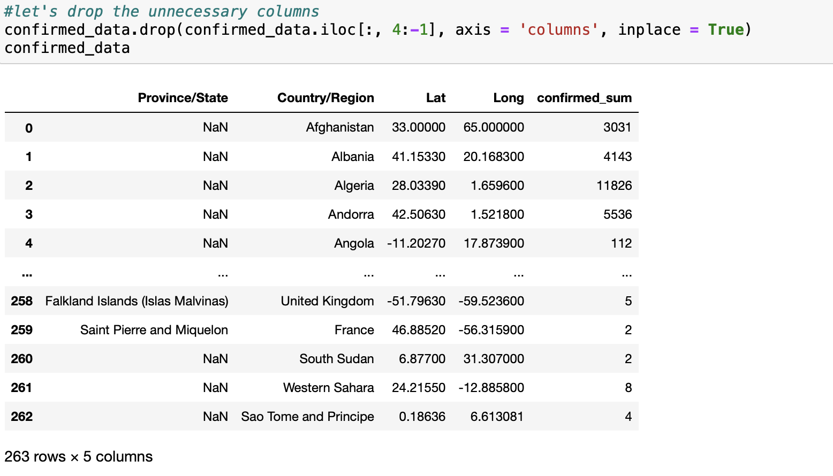

Fig. 3. File with sum and dropped columns.

Once the sums have been calculated for each file, they can be merged into one single DataFrame on the “Province/State” and “Country/Region” columns [Fig. 4]. Note that since there are four more rows in the “recovered” file, the merge results in four null values in the confirmed and deaths column. Outliers also cannot be dropped, as these are significant pieces of data. Once the files have been successfully merged, the data can now be cleaned, transformed, and scaled for further analysis.

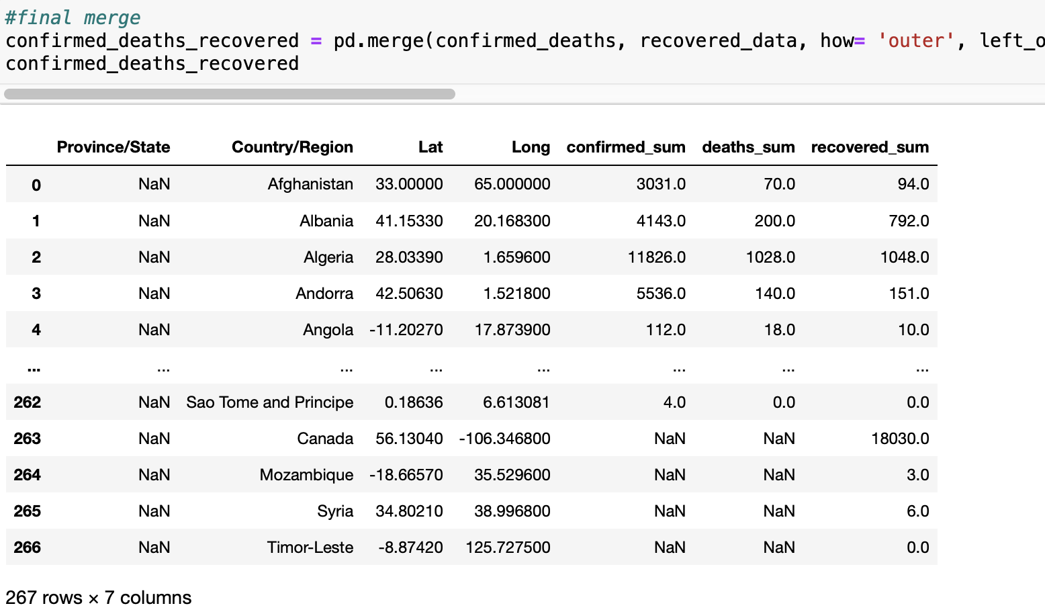

Fig. 4. Three merged files.

Upon looking at the data, it becomes evident that there are a significant number of null values in the “Province/State” column. In the context of this paper, these values are irrelevant since the only necessary location value is the country, so the column can be conveniently dropped. As a result, the “Country/Region” column reveals multiple different duplicates when filtered, which explains the reason behind the numerous null values in the “recovered_sum” column [Fig. 5]. Since “Province/State” is irrelevant to the research question at hand, the values of the duplicate rows must be summed and added to a single instance of the “Country/Region” of interest.

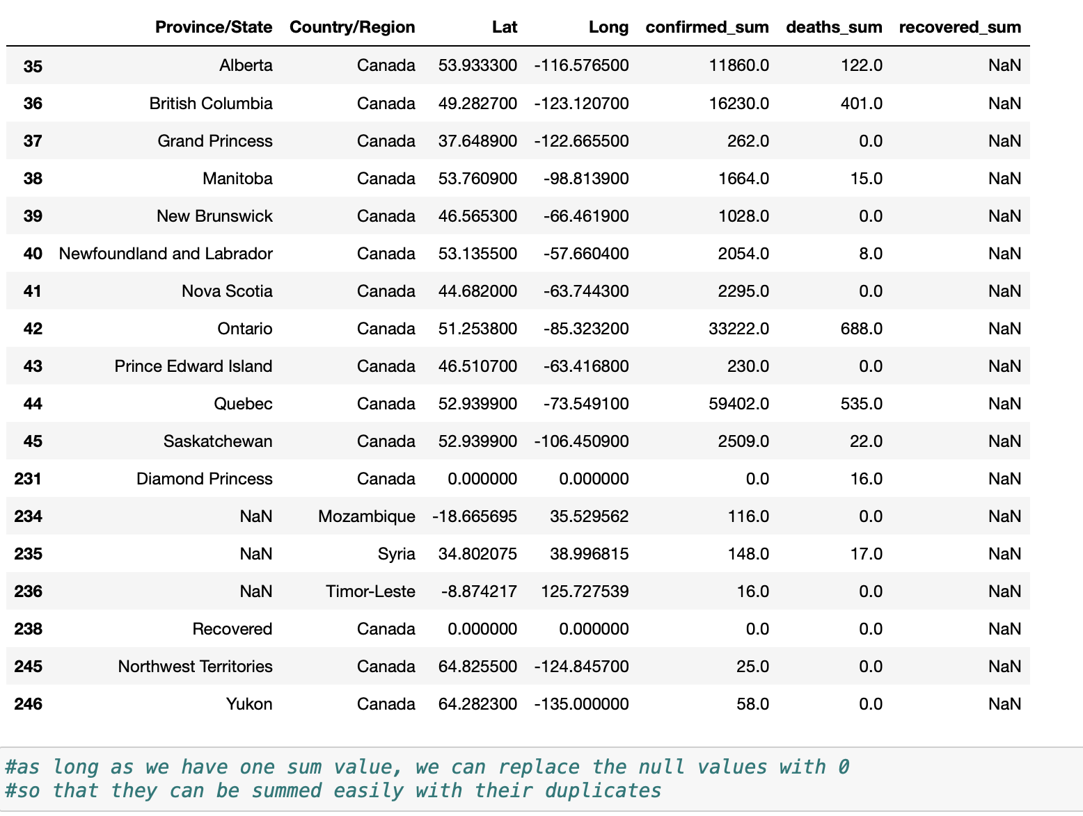

Fig. 5. Filtered duplicates.

This can be done simultaneously by summing the values while using the “groupby” function on the rows of data. Once done, the duplicate rows can be dropped and the remaining rows can be reindexed to account for the dropped rows. The file rows decrease from 266 rows to 183 upon doing so [Fig. 6]. The “Lat” and “Long” columns can be dropped, since they are irrelevant to the nature of the research question. In addition, since the sums have now been recorded in a separate “total” column, the original sum columns can also be dropped. This results in a total of four columns; “Country/Region”, “total_confirmed”, “total_deaths”, and “total_recovered”. Once complete, the data can be transformed in an effort to reach normal distribution.

Fig. 6. Dropped and reindexed file.

Taking the logarithm of the three columns yielded the best results compared to other methods. A sample curve for the “total_confirmed_sum” column has been included to show the shape of the density graph after logarithmic transformation [Fig. 7].

Fig. 7. Logarithmic density graph of “total_confirmed_sum” column.

Now that the data has been appropriately transformed, it can be properly examined with data visualization methods. Three different methods were used. The first was plotting all three relevant columns onto one single plot [Fig. 8]. This results in a wide graph with significantly large or small values, which is not ideal for analysis. However, it provides a general sense of the shape of the data. Some readjusting has to be done to the figure size to accommodate for the large number of x values. Even upon expansion of the x-axis, not all the countries can be seen; instead, only some countries are labeled and the rest must be inferred form their position on the axis. A method for isolating interesting countries can be to change the x-axis values from the “Country/Region” column and replace it with their index number. Doing so would make it easier to look at significant points, such as the high peak between Cabo Verde and Entrea.

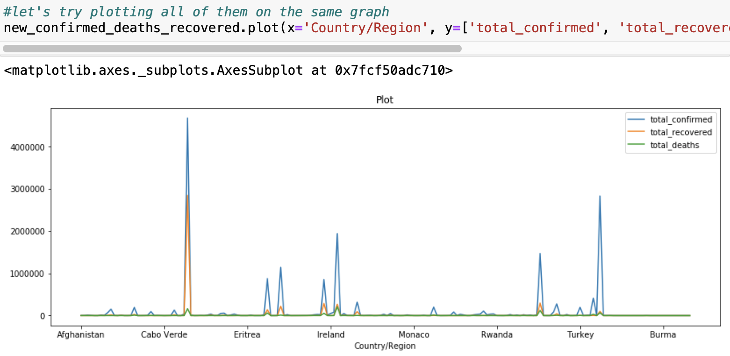

Fig. 8. Data visualization method #1.

The second method of visualization is through the use of parallel coordinates. This separates the columns into three separate points on the x-axis, and the rows into different colored lines [Fig. 9]. Some readjusting has to be done to this plot accommodate the sheer size of the data. The graph is helpful in providing a look of the general relationship between the three columns, but due to the large amount of countries under examination, the colors are hard to sort through and isolate for further investigation.

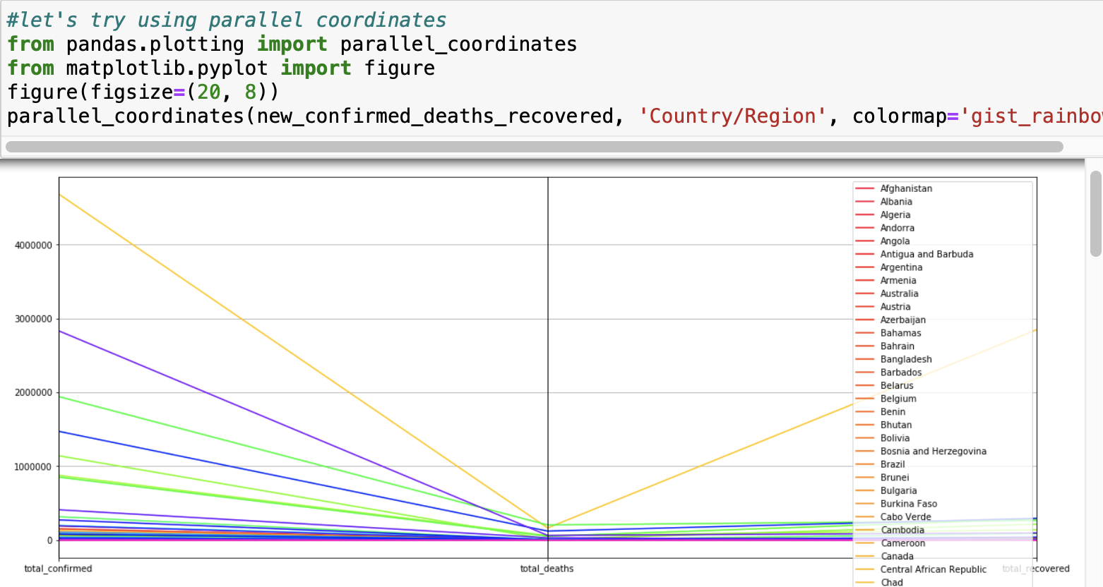

Fig. 9. Parallel coordinates plot.

The third method is more experimental. The data is projected onto a pie graph. Since the values are discrete, this method should have theoretically worked and made it simple to identify which counties had the highest count in any of the three columns. However, the presence of 183 different countries made the pie graph virtually useless. The result was quite colorful though [Fig. 10]. From these methods, it is evident that the analysis has to be conducted in a way that accommodates for each individual row.

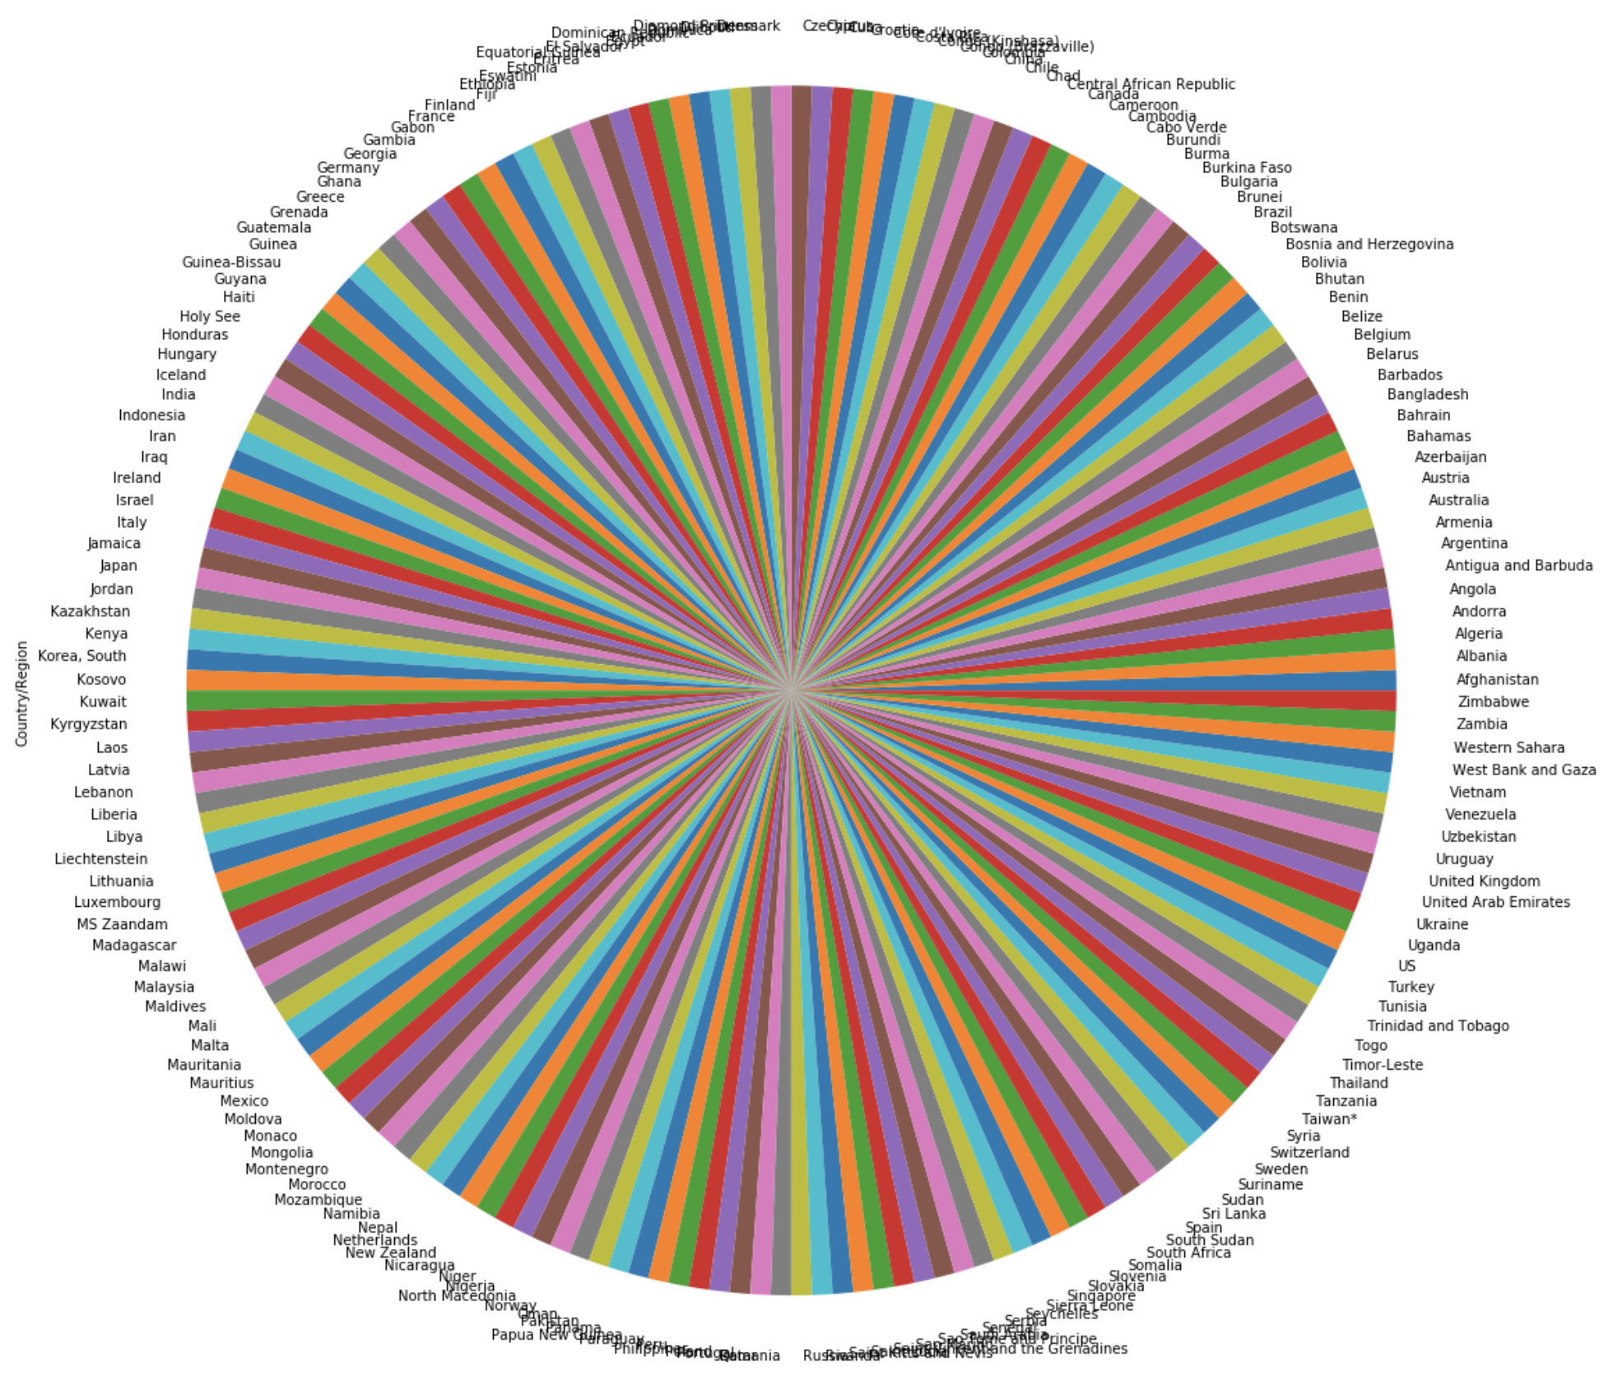

Fig. 10. Pie chart.

The most straightforward strategy is to take the ratio of the “total_deaths” column and “recovered_deaths” column. To ensure preservation of the original DataFrame, a new copy is made. After taking the ratio, some of the values result in “NaN” or a null value. This is due to there being zeroes in both columns. The solution for fixing this is simply to replace null values with “0”, as that should be the value of a ratio of zero to zero. In addition to this, there are infinite values that result from dividing a value by a zero that is present in the “total_recovered” column. In this case, the values should be dropped due to unreliability. If there are no reported cases of recovered patients, there is no certain way to determine the ratio of deaths to recovered. After these values are dropped, the file can be reindexed again [Fig. 11].

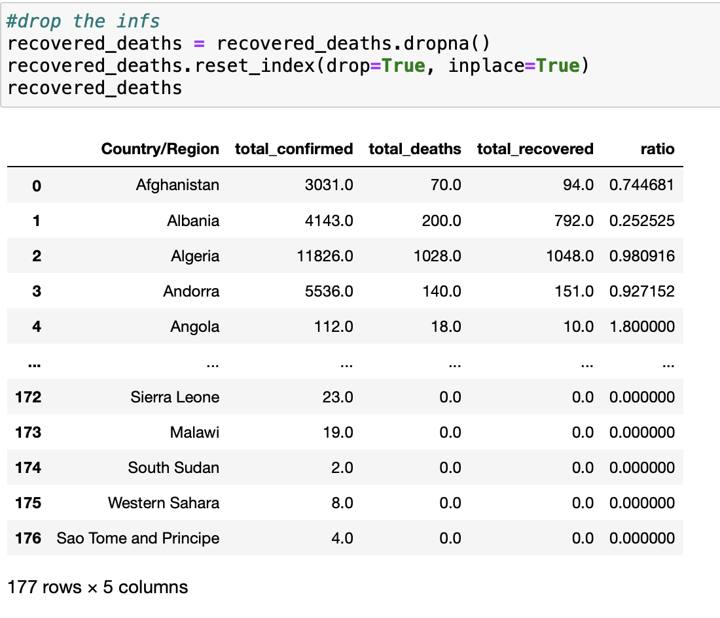

Fig. 11. File after ratio column is added and cleaned.

This results in 177 rows of data rather than the original 183 rows. To take a look at the countries with the smallest ratio of death to recovered, a query can be written. There is plenty of flexibility here; the query can be filtered to allow for ratios of zero, written to remove ratios of zero, or be specified to do anything else that could be of interest [Fig. 12]. The smaller the ratio, the higher the chance that an infected patient will recover instead of perishing. This method answers the research question; “How does the location of an individual affect their chance of recovering from the coronavirus?” But as an alternative method, the Naïve Bayes algorithm can be attempted.

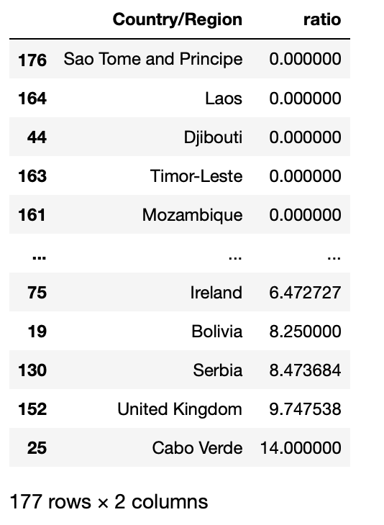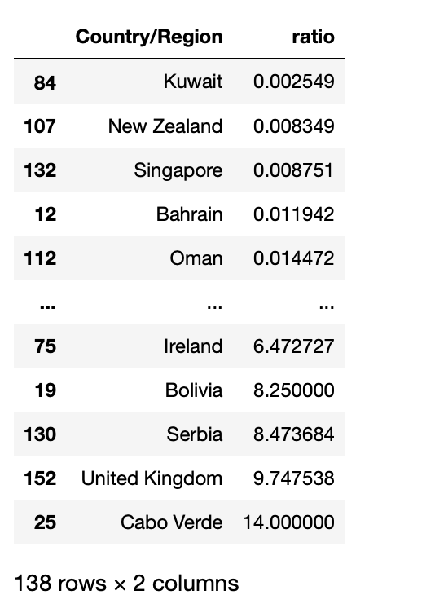

Fig. 12. Example query results.

Naive Bayes is a classification algorithm for binary and multi-class classification problems and is often described using binary or categorical input values. It can be extended to real-valued attributes called Gaussian Naive Bayes. This is the model used for assessment for this method [Fig. 13].

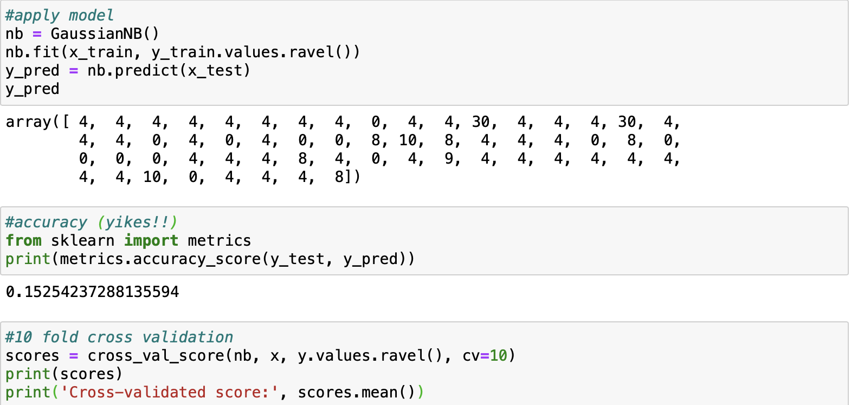

Fig. 13. Naïve Bayes, accuracy, and cross-validation.

The first step is to fit the x and y values to the model. The output results in an array. Afterwards, the model is tested for accuracy. In this case, the model tested extremely poorly for accuracy due to the wide variety of unincorporated factors that may have influenced the data.

Cross-validation is a resampling procedure that can help evaluate machine learning models like Naïve Bayes when given a limited data sample. When attempted, the cross-validation score yielded a small number, pointing to Naïve Bayes being an unreliable method.

# Results

From the two attempts to answer the question "which countries handle the virus the best," it seems that using the ratio is the more reliable method.

Since the ratio was derived from taking the quotient of deaths and recovered, the larger the ratio, the more likely the chance of death. However, the opposite is also true. The smaller the number of the ratio, the greater chance of recovery.

This method is flawed, however, since it only calculates recoverability and disregards other factors. For example, countries with very few cases could easily have a very high or low recoverability, and a number does not encompass the patients that are still ill or the resources a country has. It doesnt account for many factors, and to gain a more well-rounded view of different countries' different solutions to this virus, more research must be done. However, this is a good starting point to see which countries are doing well and use that to observe further trends.

# Discussion

There was only one member conducting this project, so all research, data analysis, and writing was consequently done by one member. Although the resulting method was crude, it is a start to direct the conversation away from the deaths and rather address the problem by trying to isolate a solution.

There were a number of problems that were addressed along the way. The three files had different numbers of rows that made preparing the data difficult, and when visualized, was difficult to analyze due to the large amount of values. When further analysis was performed, null and infinite values appeared, leading to further difficulties. This had to be countered with appropriate data cleaning techniques so that no vital information was lost. Despite various complications in handling everything was addressed as adequately as possible, yielding results that are not the most perceptive but a start to further analysis.

# Acknowledgement

I genuinely enjoyed researching and coding for this project and I must thank Dmitriy Babichenko for that. Assignments throughout the semester created a solid background necessary for carrying out this task and fostered a love for data analysis through real-life applications. The support from this class from his TA’s and the care the professor has put into the curriculum contributed significantly to my interest and completion of this paper. I greatly appreciate it.

# References

1. WHO.int. 2020. *COVID-19 Situation Reports*. [online] Available at: <https://www.who.int/emergencies/diseases/novel-coronavirus-2019/situation-reports/> [Accessed 14 April 2020].
2. Centers for Disease Control and Prevention. 2020. *Coronavirus Disease 2019 (COVID-19)*. [online] Available at: <https://www.cdc.gov/coronavirus/2019-ncov/faq.html#Coronavirus-Disease-2019-Basics> [Accessed 14 April 2020].
3. Buchholz, K., 2020. *Infographic: Coronavirus: Upward Trajectory Or Flattened Curve?*. [online] Statista Infographics. Available at: <https://www.statista.com/chart/21112/covid-19-growth-curve-selected-countries/> [Accessed 14 April 2020].